SAC MEMORIAL-NEBRASKA
November 3, 2009

Advisory Committee:
Diane Bartels, Aviation Historian and Author
Dan and Sharon Duffy, SAC Veteran and Family
Roger Lempke, Lt. Gen. (Ret) Air National Guard
Mark Musick, Maj. Gen. (Ret) Air National Guard
Ronald E. Resh, SAC Memorial-Ohio
Evonne Williams, Interim Executive Director, Strategic Air & Space Museum

We are pleased to announce the SAC Memorial-Nebraska Project.

As many of you are aware, Ron Resh led a very successful effort to place a memorial to the Strategic Air Command (SAC) at the Air Force Museum in Dayton, Ohio. Photos of that wonderful monument are attached.

My involvement in this project began when my mother, Peach Janssen, talked to me about placing a similar monument at the Strategic Air & Space Museum (SASM) in Nebraska. There were several reasons for her desire to do this. Her husband and my father, Carl A. Janssen, Lt. Col. USAF Ret, deceased, was not only a career SAC veteran, but also the first Director of what was then the Strategic Air Command Museum when it was built adjacent to Offutt Air Force Base. We feel strongly that SAC should be memorialized in the museum located in Nebraska and near what was once SAC Headquarters for so many years.

With the beautiful monument in Ohio as a model and excellent advice from Ron Resh about how to accomplish a project like this, we decided to proceed. We have received a commitment from Dodds Monuments of Xenia, Ohio, to replicate the monument they manufactured for the Air Force Museum. They sincerely look forward to their role in this project.

The monument in Nebraska will be exactly like the one at the Air Force Museum, except that it will be over seven feet in height rather than ten feet tall. It will also differ by being placed indoors in Hangar A among all of the many aircraft on display that SAC once flew. It will stand amid an increasing number of SAC exhibits. The museum will initially place metal benches around the monument, so people can sit there to pause and reflect. These benches will be replaced over time by stone memorial benches that are dedicated to individuals and units.

We have had wonderful cooperation from the museum. They are very interested in expanding their SAC exhibits. They are excited about having the monument located under the impressive SAC emblem which is on the north wall of Hangar A above their SAC exhibit area. They are looking forward to being the site of our dedication and future SAC reunions

To make this project a reality, we need to raise approximately $30,000.

The Strategic Air & Space Museum is a tax exempt 501 (c) (3) organization and all gifts to our project are tax deductible as allowed by law. Their Tax ID Number is 47-0619646. All donors to this project will receive a written acknowledgement of their contributions for their tax purposes. The museum is very supportive of our project, and they will restrict the gifts made to the SAC Memorial-Nebraska for this purpose only. If we raise more money than we need to accomplish this project, any surplus funds will be restricted to supporting additional SAC exhibits at the museum. . The museum will retain a modest administrative fee for their efforts. This expense is included in the project budget goal of $30,000. A form to accompany gifts to this project is attached.

We hope to receive contributions from both individuals and organizations that are interested in perpetuating the memory of SAC’s vital role in the defense of our country.

We anticipate it will take approximately six to eight months to make, transport, and install the monument once we have raised the necessary funds. This will give us ample time to schedule and arrange for a proper dedication. The museum would like nothing more than to welcome many SAC veterans, families and friends to such an event.

I would invite all of you who may not have visited the Strategic Air & Space Museum recently to do so. It is now located between Lincoln and Omaha just off of Interstate 80 at Exit 426. I am confident that you will be impressed by the number of SAC aircraft on display there, the SAC emblems that are in very conspicuous locations (including on the outside wall as you approach the entrance), and the growing SAC exhibit area along the north wall of Hangar A.

I will be pleased to answer any questions you might have.

Thank you for your time and attention to this exciting project.
Respectfully,

CARL A. JANSSEN, JR.
Lt. Col. USAFR (Ret)
Project Coordinator
18647 Lower Lake Rd.
Monument, CO 80132
719-488-6778
cjanssenjr@aol.com Attachment 1: SAC Memorial-Ohio Front View
Attachment 2: SAC Memorial-Ohio Back View
Attachment 3: Gift Form
Attachment 1

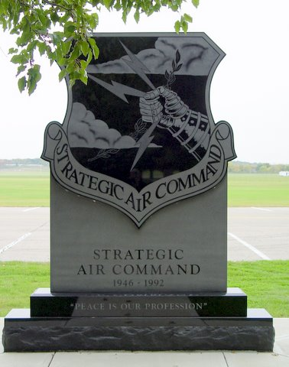

Attachment 2

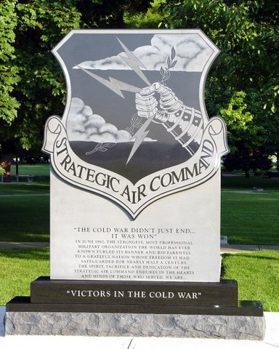

Attachment 3

STRATEGIC AIR & SPACE MUSEUM (SASM)
SAC MEMORIAL-NEBRASKA
GIFT FORM

This donation is to support the SAC Memorial-Nebraska Project.

Name: _______________________________________________________

Spouse: ______________________________________________________

Address: _____________________________________________________

City: __________________________ State: ____ Zip: _______________

Phone (main):____________________ (other):______________________

Email Address: _______________________________________________

Method of payment:

Check ______ Credit Card ______

If Check: Make your check out to SASM with a notation the gift is for the SAC Memorial-Nebraska.

If Credit Card:

Charge $___________ Master Card _____ Visa ______

Acct #_____________________________ Exp Date____________

Signature__________________________________________

Mail this form to:
Strategic Air & Space Museum
SAC Memorial-Nebraska
28210 West Park Highway
Ashland, NE 68003

