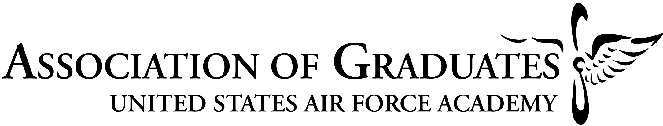

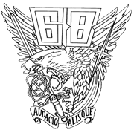
What is the 50-Year Legacy Class Program?
Class of 1968, Legacy Class for
Class of 2018

In 2000, the Class of 1964 became the first “Legacy Class”, tying itself to the incoming Class of 2004. At the Acceptance Parade on 8 August, 2000, D.J. Alberts, President of the Class of 1964, charged the new fourth class cadets to “become the pacesetters of the new age – through integrity, service, and excellence”. He stressed the shared responsibility of both classes in making the Academy what we all expect it to be – “recognized as the premier developer of aerospace leaders…leaders with impeccable character and essential knowledge…prepared and motivated to lead our Air Force and nation.”

The 40-year program started before the Class of 1959 reached its 50th year post graduation. Once ’59 reached that milestone, the AOG and USAFA began to honor them with involvement in graduation and other events. To avoid confusion and streamline legacy class involvement, the program was changed and the 50-year class is now the official legacy class. As a 1968 graduate, you are invited to return to the Academy, sit with your old squadron in Mitchell Hall, and watch as the members of the Class of 2018 celebrate their milestones.
Below are the opportunities for your class to interact with the Class of 2018 over the next four years:

June 2014
- Serve as greeters when the basics and their parents arrive. Sit on the Terrazzo and watch as the basics are sworn-in.
August 2014
- View the parade as the basics are “accepted” as fourth class cadets. Ten 1968 representatives present Contrails to the outstanding Basic Cadet from each of the ten squadrons.
October 2015
- Sit and dine with the Class as they celebrate the selection of their Class Exemplar.
10 August 2016
- Sit and dine with the Class as they celebrate their “Commitment” to the Air Force.
19 May 2017
- Sit with your spouse and dine with the Class as they receive their Class Rings.
February 2018
- Sit and dine with the Class as they celebrate 100th Night.
April 2018
- Attend the First Class Leadership Dinner. Dine with Class officers of the First Class and senior leadership of the Academy and AOG.
June 2018
- Present and fund 2LT bars to new graduates at commissioning ceremonies.

Your Association of Graduates and the Long Blue Line are counting on the Class of 1968 to guide the Class of 2018, instilling a sense of pride and heritage as they go forth as cadets and officers.

Online registration is available at www.usafa.org under Calendar, Events, closer to each event. We encourage you to keep checking our website and Checkpoints magazine for updates and opportunities to participate!

