Reese AFB UPT Class of 70-01 50-Year Reunion Itinerary

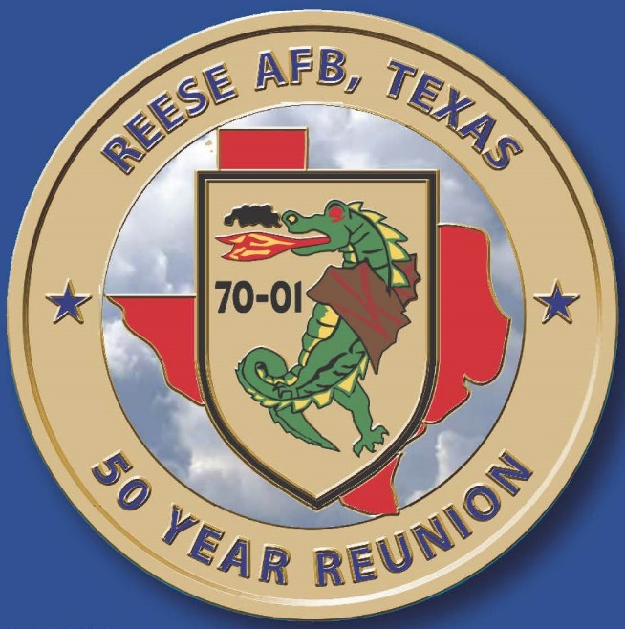

Wednesday, 25 September

Check-in at Hotel

0930 – 1230 - Reunion Registration, Name Tags, and Refreshments in Oasis Room near the pool
1430 – 1730 – Reunion Registration, Name Tags, and Refreshments in Oasis Room near the pool
Registration after 1730 – Contact Tim Davidson on cell phone: 703-772-6052
Entire Day is Free Time – Oasis Room will be open after dinner until 2200

Thursday, 26 September

0800 – Buses arrive at hotel for tour of Eglin AFB. Attire: Men: Reunion Shirt or Sports Shirt, Long Pants. Women: Reunion Shirt or Sports Shirt; Skirt, Shorts, Slacks, or Sun Dress. All wear nametags.

0815 – Buses depart for the USAF Armament Museum to pick-up Escort Officer, Shelby Daniell

0900 - Buses arrive at Air Force Armament Museum
Greeted by: 96 TW Public Affairs

0915 - Travel to 33rd Fighter Wing

0915 - 0930 - Comfort Break

0930 - 1030 - 33rd Fighter Wing Training Center Briefings
33 FW/CC, 96 TW/CC and AFLCMC/EB

1030 - 1045 - F-35 Static Display + Group Photo

1045 - 1100 - Travel to King Hangar

1100 -1145 - F-16, F-15 and Munitions Static Display and Pilot Brief + Group Photo

1145 - Depart for USAF Armament Museum

1155 - Arrive at USAF Armament Museum

1255 - Depart USAF Armament Museum for AJ's on the Bayou Restaurant

1305 - Arrive as AJ's on the Bayou for Lunch

1425 - Depart AJ's for the Island Beach Resort, by Hotel RL

1500 - Arrive at Reunion Hotel

1600 - 1800 - Refreshments in the Oasis Room by the Pool

Free time for remainder of the day. Oasis Room will be open after dinner until 2200

Friday, 27 September

0800 – Buses arrive at hotel for tour of Hurlburt Field. Attire: Men: Reunion Shirt or Sports Shirt, Long Pants. Women: Reunion Shirt or Sports Shirt; Skirt, Shorts, Slacks, or Sun Dress. All wear nametags

0820 – Buses depart for Hurlburt Field to pick-up Escort Officer, SSgt King

0850 Meet at Hurlburt Front Gate
Met by: SSgt King, 1st SOW/PA
Welcome & Introductions

0850 - 0900 Travel to AFSOC HQ building, Air Commando Room
POC: Dawn Hart, AFSOC/PA (850) 902-1544; SSgt. King (850) 603-4446

0900 - 1000 AFSOC command mission Brief/Q&A
Host: Lt Gen Slife, AFSOC/CC
Briefer: AFSOC/CCX

1000 - 1015 Travel to Base Ops

**Split into 2 groups**

1015 - 1100 Group 1: CV-22 Osprey Static Display
Briefer(s): Pilot/Aircrew
1015 - 1100 Group 2: AC-130J Static Display
Briefer(s): Pilot/Aircrew

**Switch Groups 1 & 2**

1115 - 1200 Group 1: AC-130J Static Display
Briefer(s): Pilot/Aircrew
1115 - 1200 Group 2: CV-22 Osprey Static Display
Briefer(s): Pilot/Aircrew

1200 - 1215 Travel to Base Chapel (Next to Air Park)

1215 - 1230 Comfort Break at Base Chapel

1230 - 1300 Memorial Service
POC: Col Davidson

1300 - 1400 Catered Lunch at Base Chapel (Corner Café)
POC: SSgt King

1400 - 1415 Travel to STTS Annex

1415 - 1530 STTS Mission Briefing/Tour Static Equipment
POC: TBD
Briefers: TBD

1530 - Depart STTS Annex for the Island Beach Resort, by Hotel RL

1600 - Arrive at Reunion Hotel

1600 - 1800 - Refreshments in the Oasis Room by the Pool

Free time for remainder of the day. Oasis Room will be open after dinner until 2200

Saturday, 28 September

Free Time for morning and afternoon. Oasis Room will be open from 1000 – 1600

1730 – 1830 – Banquet Reception and Bar open in Maui Ball Room. Attire: Men: Hawaiian Shirt or Sports Shirt, Long Pants. Women: Hawaiian Shirt or Sports Shirt; Skirt, Long Slacks, or Sun Dress. All wear nametags.

1830 – 2100 – Banquet and Open Microphone Session

2115 – 2300 – Oasis Room will be open

Sunday, 29 September

Official Reunion activities end. Best wishes for safe travel home.

