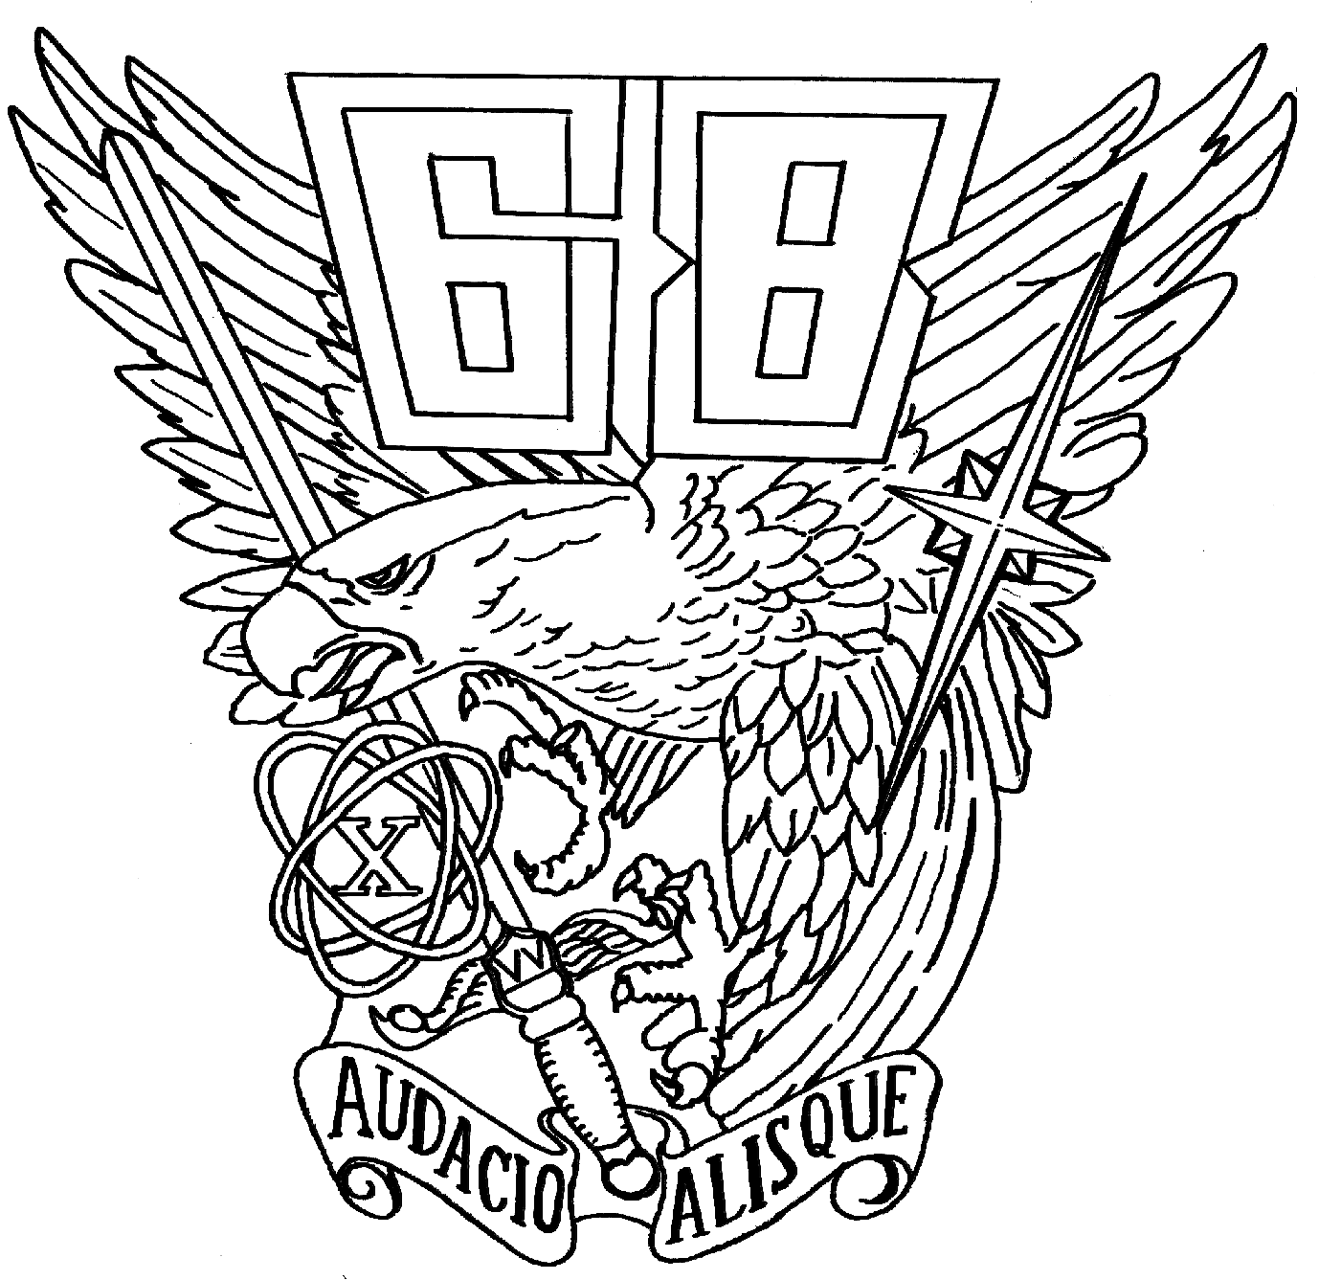

Greetings to the USAFA Class of ‘68

We are just under a year away from our 40th Reunion and your Colorado Springs classmates are hard at work to put together a top notch event. We wanted to let you know where we stand at this point so you can begin to make your travel arrangements.

WHAT WE KNOW FOR SURE: The reunion will run from Wednesday, 1 Oct 08, thru Sunday, 5 Oct 08. Headquarters will be the Embassy Suites Hotel on the north side of Colorado Springs with quick access to the Academy. The AOG will handle all the registration and administrative details for the class.

TENTATIVE PLAN FOR KEY EVENTS:
Wed: 1) registration at the Embassy Suites - 1600-2000 2) class social in early evening with hors-de-oeuvres provided by the class, no-host bar 3) dinner on your own (many restaurants in the vicinity within an easy walk)
Thurs: 1) registration all day at the Embassy Suites - 0730-1200, 1400-2000 2) spirit walk at the Academy in the morning 3) lunch with cadets in Mitchell Hall 4) individual activities in Colorado Springs in the afternoon (group activities possible, see our class website) 5) class social and dinner at the Embassy Suites (casual dress)
Friday: 1) golf 2) late registration all day at Doolittle Hall (AOG building) – 0800 – 1730 3) lunch at the Academy 4) Academy open house and presentations by Senior Staff with question time 5) Memorial Service 6) class social and dinner at the Embassy Suites, including a special presentation by the Cadet Chorale (coat and tie recommended)
Saturday: 1) pre game tailgate at the Falcon Stadium 2) beat Navy 3) post-game victory celebration at the stadium 4) dinner on your own in the local area (squadron activities recommended)
Sunday: no planned class activities, departure at your leisure

SPECIAL NOTES:
- Greg Shuey is working with the Cadet Chorale on a special presentation for our class—if you were a member start tuning your voice. Greg requests that all chorale members from our class contact him via email at gshuey@tensortech.com
- Steve McPhail is heading our efforts for a special Memorial Service—we plan to conduct it at the Cemetery if we can work the logistics and determine a suitable inclement weather option
- The Embassy Suites special rate of $109 per night includes cooked-to-order breakfast daily and access to the hotel happy hour (our class will have a separate social hour on Thursday and Friday)
- Carl and Debbie Janssen have graciously offered to host an open house for all classmates at their home in Monument on Sunday from 1000 to 1400. Directions will be provided in your welcome packet

OVER FOR MORE
WHAT YOU NEED TO DO:
- Decide on your arrival date and make travel arrangements
- Monitor the class website at usafa68.org for reunion information
- Register for reunion activities, football tickets, hotel reservations and merchandise on line thru the AOG website at http://www.usafa.org/reunion/1968/1968.aspx. Please monitor the AOG site for all updated reunion schedules and information. Note: actual registration will not be available until early June. The class website will also have a link to the AOG website to aid in the process.

OTHER:
- We are making a concerted effort to contact and encourage all surviving spouses of our deceased classmates to attend the reunion. Carl Janssen, email cjanssenjr@aol.com, is leading that effort and would be pleased to provide assistance. If you have contact with any surviving spouses please direct them to Carl to make sure they receive first class treatment.
- Non-graduate members of our class are also welcome to attend reunion activities, as they have been in the past. If you have contact with non-graduate classmates please extend the invitation and direct them to the AOG website. They will need an AOG number to register, and should call the AOG at 719-472-0300 and customer service will provide them with their number.

Hope to see you in 2008.

Gene Rose
Reunion Chairman

